Commedia Dell’arte

Teen Homeschool 2013

THE HISTORY: Commedia Dell’arte is a form of theater characterized by masked "types" which began in Italy in the 16th century and was responsible for the advent of the actress and improvised performances based on sketches or scenarios. The closest translation of the name is "comedy of craft"; it is shortened from commedia dell'arte all'improvviso, or "comedy of the craft of improvisation". Here, arte does not refer to "art" as we currently consider the word, but rather to that which is made by artigiani (artisans). Commedia dell'arte was performed by professional actors (comici) who perfected a specific role or mask.
Italian theater historians believe commedia was a response to the political and economic crisis of the 16th century and, as a consequence, became the first entirely professional form of theater.
The performers played on outside, temporary stages, and relied on various props (robbe) in place of extensive scenery. The better troupes were patronized by nobility, and during carnival period might be funded by the various towns or cities, in which they played. Extra funds were received by donations (essentially passing the hat) so anyone could view the performance free of charge. Key to the success of the commedia was the ability of the performers to travel to achieve fame and financial success.

THE PLAY: Commedia Dell'arte incorporates specific roles and characters that were "originally intended as a kind of characteristic representative of some particular Italian district or town." The character's persona included the specific dialect of the region or town represented. Additionally, each character has a singular costume and mask that is representative of the character's role. Audiences came to see the performers, with plot lines becoming secondary to the performance. The classic, traditional plot is that the innamorati are in love and wish to be married, but one elder (vecchio) or several elders (vecchi) are preventing this from happening, leading the lovers to ask one or more zanni (eccentric servants) for help. Typically the story ends happily, with the marriage of the innamorati and forgiveness for any wrongdoings. There are countless variations on this story, as well as many that diverge wholly from the structure.

THE CHARACTERS: The characters of the commedia usually represent fixed social types, stock characters, such as foolish old men, devious servants, or military officers full of false bravado. In commedia each character embodies a mood: mockery, sadness, gaiety, confusion, and so forth. Commedia dell'arte has three main stock roles: servant, master, and innamorati (lovers). The servants or the clowns are referred to as the Zanni and include characters such as Arlecchino, Brighella and Pedrolino. Shakespeare's The Tempest is drawn from a popular scenario in the Scala collection, his Polonius (Hamlet) is drawn from Pantalone, and his clowns bear homage to the zanni. Since the productions were improvised, dialogue and action could easily be changed to satirize local scandals, current events, or regional tastes, while still using old jokes and punchlines. Characters were identified by costumes, masks, and props, such as a type of baton known as a slapstick. These characters included the forebears of the modern clown, namely Harlequin (arlecchino) and the other Zanni.

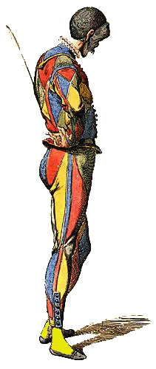  Arlechinno (Harlequin)  Movement: Has an increased gravitational pull is compensated by an irrepressible upward energy in the torso: Caliban and Ariel united in the same body. Elbows are bent, arms in a jug-handle position, or hands on hips with thumb in belt. Feet in 4th Position with head set down and forward off shoulders. Constantly in a low position, especially when in the presence of characters of a higher stature. Hunched over from carrying bags, chairs, etc. Joints loose and floppy, elbows up, knees bent, head cocked, etc. Almost like in poses of a string puppet. Very Balletic, does the splits, curved over in a reverse “C”, or any other extreme acrobatic position. Legs bow-legged as much as possible, with crisp isolated movements, such as pivoting the torso forward from the hips.  Costume: Flat shoes, bright colors in a diamond pattern. A tight-fitting jacket and trousers, sewn over with random, odd-shapen patches of green, yellow, red and brown – possibly remnants of leaves… A shape-shifter: he frequently adopts disguises and cross-dresses without demur. | Mask:  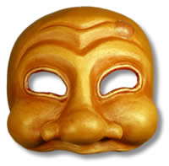  Lazzo:  - Likes to stick his head through people’s legs, arms or over their shoulder. Often uses other characters as a shield whenever possible.  - Loses control and flails around wildly like an octopus on ice.  - Somersault whenever picking something up or moving to a lower level or from one side of the stage to the other.  - Likes to scream whenever injured or upset and continue the incredible and unbelievable rant until either silenced or knocked unconscious.  - Slides across stage area whenever possible in making entrances or exits.  - Likes to add his own thoughts or opinions to messages or orders.  - Misuses props, or uses them not for their intended purposes as much as possible.
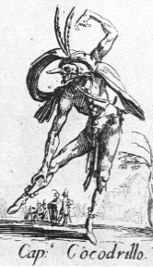  Il Capitano  Movement: Feet planted apart in order to occupy maximum space, chest pushed forward, back straight, hips wide. The heels of his high boots come down first, then the foot rolls on to the ball. Straight back, unlike zanni. Big strides. Step off on ball of foot giving lift and bounce to step. Feet on ground, head in clouds. When he hears a frightening noise he drops everything, but only succeeds in running on the spot, head thrown back, arms in the air, kicking his feet forward and howling piteously. The whole world is an audience. Stops whenever he sees the actual audience and makes a salutation so that he can be admired.  Costume: Satire on military profession, therefore dress follows period changes of uniform. Feathered helmet or hat (mon panache). Huge boots (not necessarily a matching pair) with exaggerated garters. Spanish varieties have exaggerated ruff. Costume sometimes diagonally striped or slashed in the style of Francois I. But whatever the style, close scrutiny reveals the truth: ‘Magnificent in words, but his purse is always empty and under his beautfully richly damascened cuirass he wears but a frayed and tattered leather jerkin’. | Mask: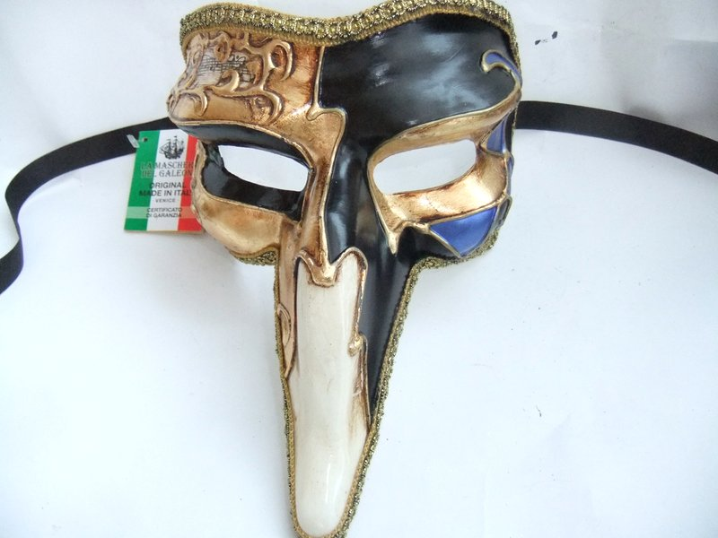  Lazzi:  - Lazzo of Excuses - Capitano goes into a long spiel about how he could kill whoever he is talking to, how he could destroy them in so many ways with so much ease, but there is always some silly reason why he can’t.  - Lazzo of Counting - He beats Arlecchino for some reason ten times, but keeps losing count and starting over.  - Lazzo of Killing - Capitano and Arlecchino decide to kill Pantalone. To demonstrate to the other how he would kill Panatlone, he says, “You be Pantalone”, and strangles the other. As Arlecchino nearly passes out, he says, “Now you be Pantalone” and returns the favor.  - Lazzo of the innocent bystander – Brighella and Pedrolino meet face to face and hurl insults, Capitano tries to keep them from fighting and gets beat up by both of them.  - Lazzo of being afraid of Columbina’s love.
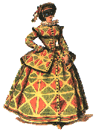  Colombina:  Movement: One knee bent, the other leg extended. Slight forward tilt from the hips to show best features. Tiny waist and wide hips. Poses with hips cocked out, bust out, and hands extended behind back. Often leaning forward or standing upright and "perky" with arms at sides and palms parallel to the ground. Loves Arlecchino, but sees through him. Feels a need to look after him, educate him in the hope that he too can break the bounds of being a fixed type. She therefore scolds him, punishes him, deserts him, takes him back, but in the end he does not change and she has to accept him for what he is, which is still more lovable than Il Dottore, Pantalone , Il Capitano, etc.  She can be very affectionate to other characters as well, and her affections seem to flow through her physically, but she always holds something back. As a result she is pestered by other men, especially Il Capitano and Pantalone. She is always ready to help the Lovers, perhaps through natural sympathy with their plight.  Costume: Dressed like her mistress or Arlechinno, but always had a small apron. Better dressed than male servants since she is a lady’s maid. Mob cap and apron, wearing a ‘folly’ dress underneath. Skirts usually fell just below the knee. Neckline of bodice low and often frilled. Several colors of material. | Mask: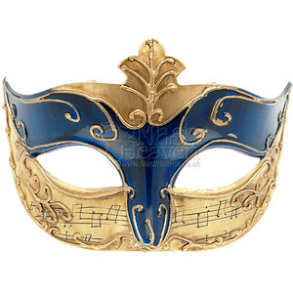Lazzi:  - She appears almost if not before her name is called, always being on step ahead of her master.  - She finishes sentences for her master, which she sometimes uses in her favor.  - When a situation gets out of control, she becomes the dominant voice to put everyone and everything back in its place.  - She beats the male characters, sometimes even her master.  - She requests other characters to tell her how important she is.
Il Dottore  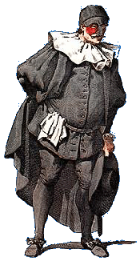  Movement: Often has a book and a white handkerchief. Stiff, leaning forward with hand on face, usually tapping forehead or stroking beard in a pensive manner. Poses in “The Thinker” often. Upright and proud like a scholar and an arm out to dictate. He is grande, even grandissimo: his huge size comes directly from Carnival and contrasts with Pantalone. From Bologna, the home city of Italy’s oldest University, not that he ever went to it. Specializes in everything, and can talk a load of old boloney about it. Very oral, both in and out: he also eats a lot (Bologna is the home of lasagne). He is essentially belly, not intellect-centered. Il’Dottore is inclined, like Pantalone, to be stingy, but in his case it is because he doesn’t have any money. He is never put off his stroke by parody, interruption, or even physical abuse.  Costume: Large, doctoral robes and hats, often in black. Tight leggings to exaggerate his large waist size. Long jacket with black coat over-reaching to his heels, black shoes, stockings and breeches, and black skull-cap. | Mask:  Lazzi:  - Talks to excess, often to the point where he has to be carried off by other characters, still talking.  - Believes someone suffers from an ailment which they obviously do not. Offers to cure them.  - Spontaneously diagnoses performers on stage.  - Tries to enlist assistance to help him perform experimental surgeries on himself and others.  - Performs random experiments in the name of science and medicine.  - Accidentally takes his own medicine.

Pantalone  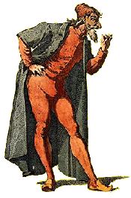  Movement: Bent over as if spine just went out, supports his upper body with cane sometimes. Usually leaning slightly forward with nose in the air. One hand behind back or holding purse, other hand on cane. Pantalone operates on the assumption that everything can be bought and sold, and this turns out to be true, with the exception of loyalty (and love). But he also loves money for its own sake and will therefore only part with it when there is no other option.  Costume: Wore red breeches, a red vest, and a black ankle-length coat. Lean and Scrawny, often short in stature. Often with a codpiece or money sack hanging from the middle of his belt. Often wore gold chains and rings. | Mask:  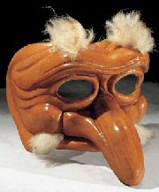  Lazzi:  - Sometimes falls flat on his back on hearing bad news (usually financial). Like a turtle, he cannot then right himself.  - He typically wants to marry the same woman as his son Flavio, or is too mean to provide a dowry for his daughter, Isobella.  - When things do not go his way he quickly slips into emotional extremes, particularly enraged petty tyranny  - The hands (which he can’t keep to himself) flutter continuously, gesticulating each thought as it comes into his head. The only way he can stop this is to hold them behind his back, underneath his cloak.

The Lovers  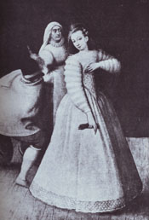  Movement: Prima donna, Foppish, Inamorata. Isabella is usually Pantalone’s daughter. Leans to one side with one leg pointed outwards, and hands in praying position touching cheek as if sleeping. Often puts the back of his/her hand on a forehead tilted back as if in agony. Poses with his/her chin resting on hands laying on top of each other or fingers interlocked and the head slightly tilted. Ladies have their hips usually cocked to one side. Both male and female have feet always in ballet positions. Exaggerated movements of the hands, like feathers flapping in the wind. Often manipulating hankie, flower, fan…frequently looks in hand mirror. Any imperfection can spell disaster.  Costumes: The latest fashion, fancy and pristine. | 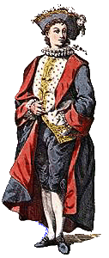  Mask: No actual mask, but heavy make-up. Mascara and beauty spots for both sexes. The make-up in fact becomes a mask enabling performers to play the role well into middle age, or even beyond  Lazzi: The lovers exist very much in their own world- and in their own world within that world. Self-obsessed and very selfish, they are more interested in what they are saying themselves and how it sounds than in what the beloved is saying. They are primarily in love with themselves, secondarily in love with love, and only consequentially in love with the beloved. What they learn, if anything, from the tribulations of the scenario is the need to reverse these priorities.  They do, however, come off better than most other Commedia characters: there is no viciousness in them, and less to be reproached for – except vanity and vapidness, which, given their parents, they can hardly be blamed for. They represent the human portential for happiness.

